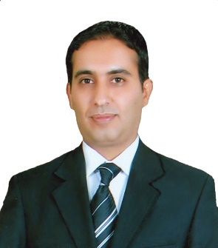
CV(Curriculum Vitae

University of Baghdad-College of Education/IbnRushd

First: Academic Certificates

Full Name | Dhea Mizhir Krebt | Academic Certificate | Ph.D.
Academic Rank | Assistant Professor | Faculty | College of Education Ibn Rushd
Major | Methods of Teaching English
Credentials
Bachelor(BC.)
University | College | Department |  | Year
Baghdad | College of Education Ibn Rushd | English |  | 2006
Master(M.D)
University | College | Department |  | Year
Baghdad | College of Education Ibn Rushd | English |  | 2010
Thesis Topic in Arabic | An Assessment of Oral Communication Strategies Used by Iraqi EFL Teachers and Students at Intermediate Schools
Doctorate(PH.D)
University | College | Department |  | Year
Baghdad | College of Education Ibn Rushd | English |  | 2013
Dissertation Topic in Arabic | The Effect of Teaching Listening Strategies Programme on Iraqi EFL University Students Listening Comprehension and Strategies

Second: Courses

The Course Title | Date
Arabic Language | 28/4/2013

Third: Academic Researches

No. | Topics
 | The effect of role play on EFL students
 | An assessment of Oral Communication Strategies used by Iraq iEFL students

Fourth: Occupation/Status

No. | Title | Position | From year to …
 | Head | Head of English Department | 206-2018
 | Coordinator | Coordinator of higher studies | 2016

Fifth: Teaching Experiences

No. | Subject | Stage | University/College/Dep.
 | Testing | Fourth | College of Education Ibn Rushd, English Dep.
 | Listening and speaking | First | College of Education Ibn Rushd, English Dep.

Sixth: Activities

No. | Activity | No. of Times
 | Committee Membership | 5
 | Conferences | 3
 | Symposium | 5
 | Workshop | 3
 | Social Activities | 1
 | Academic Seminar | 4

Seventh: Higher Studies Supervision

No. | Student’s Name | Thesis/Dissertation Topic | Academic Degree/Date
 | Tulba Ahmed | The Effect of Using FAFT strategy on Iraqi Preparatory school students | Master, 2018

