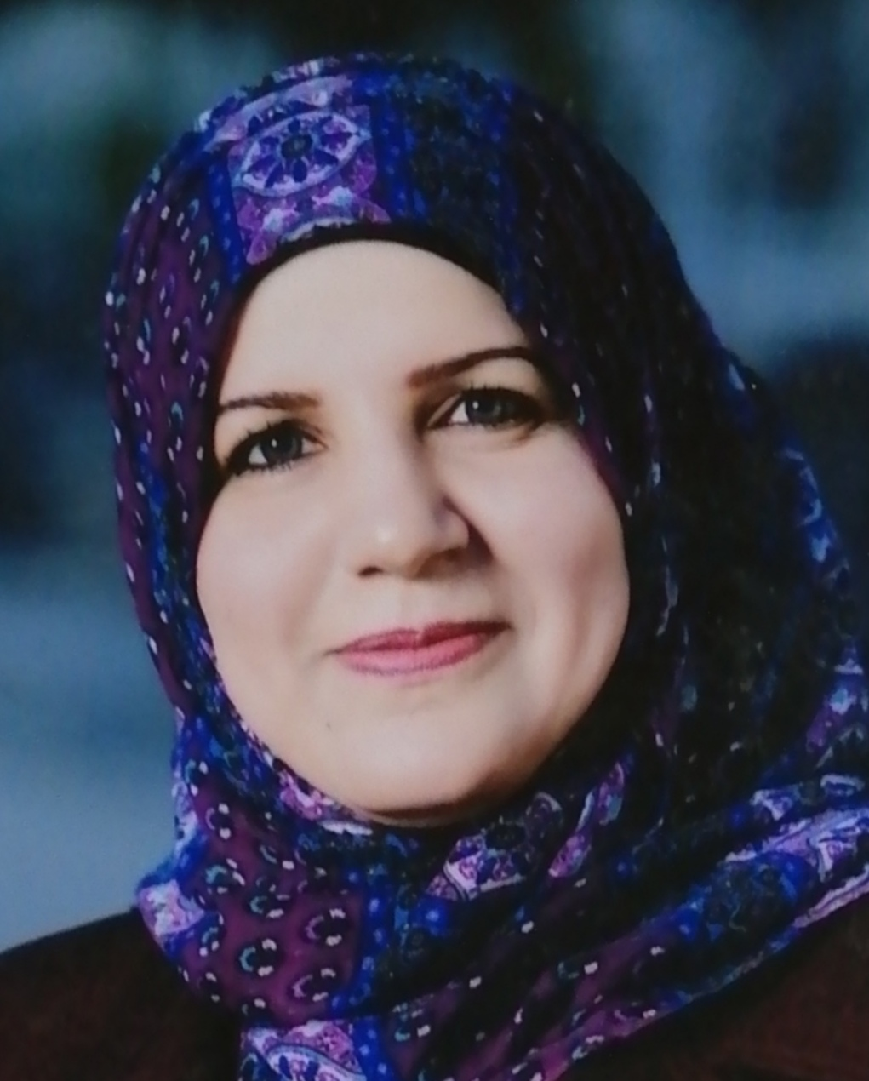
Personal Details:

Asst. Prof. Huda Abed Ali
Permanent Faculty member
Department of English Language
College of Education, Ibn-Rushd
University of Baghdad, Baghdad/Iraq
E-mail: engmsahuda1978@yahoo.com
Mob. : +964 7706 816 203
Sex: Female

Education:
∙ M.A, English Language,Thesis “Basic and Derived Syntactic Structures in James Joyce's Short Stories”. Baghdad University
∙ B.A, English Language, Project “Social Factors Leading to English Language
Change”. Baghdad University

Concentrations:
Syntax, Stylistics, Discourse Analysis, Development of Language to TOEFL level, andGRE, SAT, PBT TOEFL, IBT TOEFL

Teaching Experience:
∙ Oct. 2004 till now// Lecturer, English Dept., Baghdad University
Courses: Grammar, Phonetics, Composition, Conversation, Linguistics, Essay and
Methods of Research, Listening and comprehension.
∙ Oct. 2004 to June 2005 // Lecturer, Dept. of History, Baghdad University
Courses: Grammar, Composition
∙ Oct. 2006 to June 2009// Lecturer, English Dept., College of Arts, Kufa University.
Courses: Syntax, Composition, Grammar, Phonetics and Phonology, Essay and
Methods of Research
∙ Oct. 2011 to June 2012// Lecturer, College of Nursing, Baghdad University
Master and PhD Courses: Grammar, Essay, and Conversation.
∙ Oct. 2012 to June 2013 Lecturer, Departments of Materials Engineering and Computer Science & Electromechanical Engineering Department, University of Technology.
Master and PhD Courses: Grammar, Essay, and Communication.
∙ Oct. 2016- till now: teaching master students at English Dept. different courses: Contemporary English Grammar, Psycholinguistics, Methods of Research, and Thesis Writing.

Positions, Responsibilities, and Research Skills:
∙ Member of TOEFL supervisor committee in TOEFL Center at KUFA University,
(2007), and member in scientific committee at KUFA University
∙ Course at ETS Institution (Amman/Jordan) for supervision of TOEFL and other
five global tests, (2008).
∙ Director of Cultural Relationships at KUFA University, (2008).
∙ Director of TOEFL Centre at KUFA University, (2008).
∙ Knowledge in branches of Linguistics (Semantics, Phonetics, and Syntax).
∙ Extensive knowledge in Syntax and Stylistics.
∙ Completion of a distance learning program “ Shaping the Way We Teach
English”/Fall Course at University of Oregon in USA (2009)
∙ Completion of online course “Building Teaching Skills”/ University of Oregon
(2009)
∙ Completion of online course “Strategies and Styles of Learning [SSL]”/ University of Oregon (2010)
∙ Participating in a workshop of Supervising the students who like to complete their studies / Sulaymania (February-2010)
∙ Participating in a workshop of Supervising the students who like to complete their studies [ for Advanced Advisors only]/ Erbil (May-2010)
∙ Participating in a workshop for Training the Trainers [TOT], Baghdad (May- 2010)
∙ Participating in a course in Amman-Jordan for supervising TOEFL tests (2008)
∙ Participating in an international program for English Teachers all over the world
"Teaching English as a Second Language" / United States of America, (March-
April, 2010).
∙ Attending TESOL Conference/ USA (2010)
∙ Completion of Grant and Proposal Writing Course/ Baghdad, (July-2011).
∙ Member of TOEFL supervisor committee in TOEFL center at BAGHDAD
University (2010-2011).
∙ Completion of Summer 2012 Professional Development Workshop/ Georgia State University,USA.
∙ Participation in a study abroad workshop, Cincinnati University, USA, which was held in Baghdad February 2015.
∙Head of TOEFL & IC3 center at College of Education, Baghdad University [December, 2014]
∙Completion of a workshop of developing human resources [December, 2014]
∙Completion of skills of body language diploma from global academy of training and consulting [January,2015]
∙Participated in the conference of College of Education, Baghdad University as a researcher and a session reporter for the first committee .
∙ Member of the {English and Computer Proficiency Committee} at the MOHESR (2016- till now)
∙Member of TOEFL supervisor committee in TOEFL center and the Consultation Bureau, College of Education (Ibn Rushd) at Baghdad University (2018).
∙ Member of different committees in different national and international conferences, and the spokeswoman sometimes for certain academic and cultural occasions.
∙Head of Translation Unit at the Minister's Office (2016-2017)
∙ Responsible of (14) Iraqi Universities Committees at the Minister's Office/ Advisory Board (2016-2018) , added to being a translator for the Minister.
∙ Head and a member of many committees at the MOHESR (2016-2018)
∙Responsible for checking the electronic website of the Ministry of Higher Education and Scientific Research linguistically
∙ Linguistic supervisor of many theses and dissertations in different scientific fields.
∙ The linguistic expert of the scientific journal (Al- Ustath) in the College of Education (Ibn Rushd)
∙The linguistic expert of the scientific journal (Ishraqat Tanmawya) for the (Al- Araqah Foundation; A scientific & cultural Institution.
∙ Rapporteur of some scientific sessions in conferences.
∙ Head of TOEFL Center (January 2019- till now.
∙ Coordinator of many scientific sessions at international conferences.

Published Papers:
∙ Huda, A.A (2008) Dictionary Use at the University of Kufa: A Case Study
∙ Huda, A.A (2010) Investigation of the Social Factors Leading to Language Change
∙Huda, A.A (2011) English Prepositions: New Perspectives.
∙ Huda, A.A(June, 2015) Figuring out the intended meaning of intonation in some English conversational utterances.
∙ Investigating the effect on body language on the leaders' styles (August, 2015).
∙ Huda, A.A (September, 2015) Linguistic and stylistic features of the advertisements language and their effects on customers.
∙ A Linguistic Investigation of Contextualization in Religious Discourse (June, 2018)
° The Significance Of Freud'sTheory The Uncanny In Nella Larson's Passing: A Psychoanalytic Study (Sept. 2019).

