CV (Curriculum Vitae)
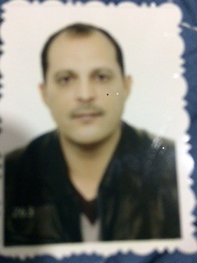

University of Baghdad-College of Education/IbnRushd

First: Academic Certificates

Full Name | MAJID RASIM YOUNUS | Academic Certificate | PhD
Academic Rank | Instructor | Faculty | College of Eductaion
Major | Linguistics
Credentials
Bachelor (B.A)
University | College | Department |  | Year
Baghdad | College of Education | Department of English |  | 1996
Master (M.A)
University | College | Department |  | Year
Baghdad | College of Education | Department of English |  | 1998
Thesis Topic | Investigating Iraqi College Students’ Production of English Intra-Word and Inter-Word Consonant Cluster
Doctorate (PhD)
University | College | Department |  | Year
Baghdad | London Met University | Department of language Studies |  | 2018
Dissertation Topic | Speech Intelligibility: A Study of Iraqi EFL learners’ Accented English

Second:Courses

The Course Title | Date
NVivo  طرائق بحث  Referencing  طرائق تدريس  دورة سكوبس  دورة بوابة الباحث | 2016  2016  2015  1996  2019  2019

Third:Academic Researches

Topics
1- phonological adaptation of English loanwords into Iraqi Arabic

2-Morphophonemic analysis of English derivatives by Iraqi College Students

3-Investigating Iraqi College Students' production of English inter word and intra word consonant clusters
4- Speech intelligibility a study of Iraqi EFL learners’ accented English

Fourth:Occupation/Status

 |  | Title |  | Position |  | From year to …
 | Ministerial Committee |  | Ministry of Higher Education |  | 2014-2013
 | Manager of the advisory board |  | College of Education |  | 2014-2012
 | Manager of TOEFL center |  | College of Education |  | 2014-2012

Fifth:Teaching Experiences

No. | Subject | Stage | University/College/Dep.
 | Grammar | First | University of Baghdad
 | Comprehension | First | University of Baghdad
 | Phonetics | Second | University of Baghdad

Sixth:Activities

Activity | No. of Times
Committee Membership | 4444
Conferences | 5
Symposium | 7
Workshop | 9
Social Activities | 3
Academic Seminar | 7
Seventh:Higher Studies Supervision

No. | Student’s Name | Thesis/Dissertation Topic | Academic Degree/Date

